

***UNIVERSITY OF PETROLEUM AND ENERGY STUDIES***

***DEHRADUN***

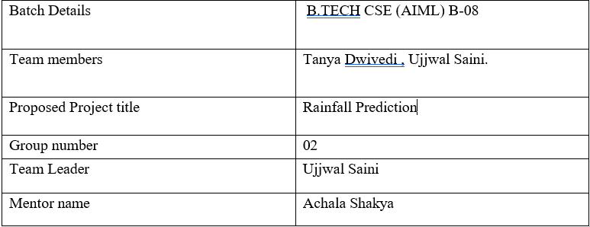

# *Introduction of the project :*

*Rainfall prediction is significant not only on the micro but also on the macro level. The study is of significance with respect to its vital contribution in the field of agriculture, water reserve management, flood prediction and management with an intention to ease the people by keeping them updated with the weather and rainfall prediction. It is also important to be utilized by the agricultural industries for keeping their crops safe and ensure the production of seasonal fruits and vegetables by updated rainfall prediction. The study will also be significant for the flood management authorities as more precise and accurate prediction for heavy monsoon rains will keep the authorities alert and focused for an upcoming event that of which the destruction could be minimized by taking precautionary measures. The rainfall prediction will impressively help in dealing with the increasing issue of water resource management; as water is a scarce resource and it needs to get saved for the benefit of human beings themselves. Also, it will help the people to manage and plan their social activities accordingly.*

***Link of the GitHub account***

<https://github.com/Ujjwal908/RainfallPrediction>

On my GitHub I uploaded this project with its report, presentation and running code.

This is my final project for the end term evaluation in my core subject predictive analysis.